EAST GIPPSLAND SHIRE LIBRARIES –
Book Club Set List

 | Author | Book Details
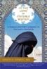 | Ahmed, Qanta | In the Land of Invisible Women  In this stunningly written book, a Western trained Muslim doctor brings alive what it means for a woman to live in the Saudi Kingdom. The book vividly depicts the shunning and shaming, racism and anti-Semitism, but the surprise is how Dr. Ahmed also finds tenderness at the tattered edges of extremism, and a life-changing pilgrimage back to her Muslim faith.  NON-FICTION
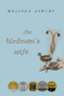 | Ashley, Melissa | The Birdman’s Wife  Inspired by a letter found tucked inside her famous husband’s papers, The Birdman’s Wife imagines the fascinating inner life of Elizabeth Gould, who was so much more than just the woman behind the man.  FICTION
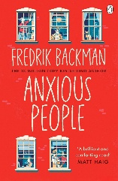 | Backman, Frederik | Anxious People  A failed bank robbery turns into a bizarre hostage situation, where eight strangers confront their secrets, fears, and unexpected connections in a story full of heart, humor, and hope.  FICTION
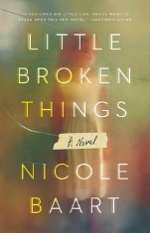 | Baart, Nicole | Little Broken Things  When Nora leaves a young girl with her sister Quinn and begs her to keep the child hidden, long-buried family secrets resurface. As Quinn, Nora, and their mother Liz seek the truth, they’re forced to confront old wounds and protect a child whose past threatens them all. Little Broken Things is a tense story of sisterhood, secrecy, and loyalty.  FICTION
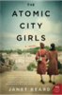 | Beard, Janet | The Atomic City Girls  What you see here, what you hear here, what you do here, let it stay here.” In November 1944, eighteen-year-old June Walker boards an unmarked bus, destined for a city that doesn’t officially exist. In the bestselling tradition of Hidden Figures and The Wives of Los Alamos, comes a riveting novel of the everyday women who worked on the Manhattan Project during World War II.  FICTION
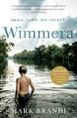 | Brandi, Mark | Wimmera  Set in rural Victoria during the late 1980s, this haunting debut follows best friends Ben and Fab as they navigate a long, hot summer filled with cricket, yabbying, and unspoken trauma. When a mysterious stranger arrives, their lives take a dark turn. Twenty years later, a body in the river forces Fab to confront the past. A subtle, unsettling story of friendship, violence, and the shadows cast by childhood.  FICTION
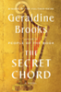 | Brooks, Geraldine | Secret Chord  Peeling away the myth to bring the Old Testament's King David to life in Second Iron Age Israel, Brooks traces the arc of his journey from obscurity to fame, from shepherd to soldier, from hero to traitor, from beloved king to murderous despot and into his remorseful and diminished dotage.  FICTION
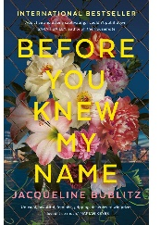 | Bublitz, Jacqueline | Before You Knew My Name  This is not just another novel about a dead girl. Two women—one alive, one dead—are brought together in the dark underbelly of New York City to solve a tragic murder. When she arrived in New York on her eighteenth birthday carrying nothing but $600 cash and a stolen camera, Alice Lee was looking for a fresh start.  FICTION
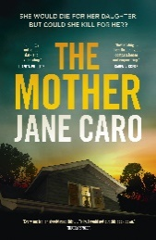 | Caro, Jane | The Mother  When Miriam’s daughter withdraws after moving to the country, a devoted mother begins to suspect that something is deeply wrong—beneath the surface of family love lies a chilling mystery.  FICTION
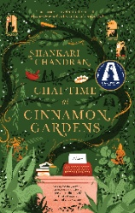 | Chandran, Shankari | Chai Time at Cinnamon Gardens  Set in a Sydney nursing home founded by Tamil refugees, this award-winning novel explores racism, migration, and identity across generations. As residents share stories from Sri Lanka’s civil war and confront prejudice in contemporary Australia, the book celebrates the power of storytelling to heal, connect, and challenge injustice.  FICTION
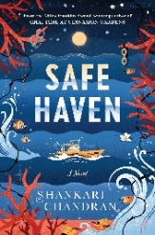 | Chandran, Shankari | Safe Haven  Set in a remote island detention centre, this powerful novel follows Fina, a refugee advocate arrested after exposing inhumane conditions. As a mysterious death draws investigator Lucky into the story, the book explores themes of displacement, justice, and the search for belonging. Chandran’s gripping narrative challenges Australia’s refugee policies and celebrates the resilience of those seeking safety.  FICTION
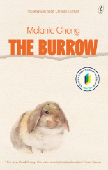 | Cheng, Melanie | The Burrow  Through characters like Daniel, a struggling artist, and his sister Kat, a psychiatrist, this poignant novel weaves stories of identity, isolation, and the fragile threads of human connection. The novel delves into themes of mental health, loneliness, and connection, set against the backdrop of cultural and personal displacement.  FICTION
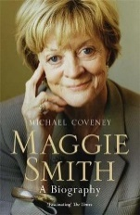 | Coveny, Michael | Maggie Smith : A Biography  This insightful portrait of Dame Maggie Smith traces her journey from a solitary childhood in Ilford to global fame on stage and screen. With access to personal archives and interviews, Coveney explores her iconic roles—from The Prime of Miss Jean Brodie to Harry Potter and Downton Abbey—while revealing the wit, resilience, and complexity behind one of Britain’s most beloved performers.  NON-FICTION
 | Dalton, Trent | Boy Swallows Universe  Brisbane, 1983: A lost father, a mute brother, a mum in jail, a heroin dealer for a stepfather and a notorious crim for a babysitter. It's not as if Eli's life isn't complicated enough already. He's just trying to follow his heart, learning what it takes to be a good man, but life just keeps throwing obstacles in the way - not least of which is Tytus Broz, legendary Brisbane drug dealer.  FICTION
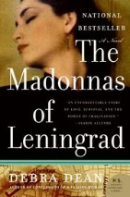 | Dean, Debra | The Madonnas of Leningrad  As Marina’s memory fades in the present day, she relives her youth during the brutal Siege of Leningrad, where art and imagination helped her survive one of WWII’s darkest chapters.  FICTION
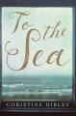 | Dibley, Christine | To the Sea  When seventeen-year-old Zoe Kennett vanishes from a Tasmanian beach house, Detective Tony Vincent is drawn into a mystery that spans generations. As four storytellers share tales blending Irish folklore and family history, Tony must separate myth from reality to uncover the truth. A lyrical and haunting debut that weaves police procedural with magical realism  FICTION
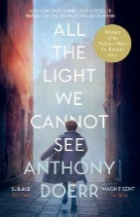 | Doerr, Anthony | All the Light We Cannot See  The story is set during World War II, a time of immense turmoil and uncertainty. We follow the lives of two main characters, Marie-Laure LeBlanc and Werner Pfennig, who come from very different backgrounds but are both profoundly affected by the war.  FICTION
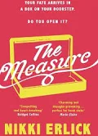 | Erlick, Nikki | The Measure  Eight ordinary people. One extraordinary choice. It seems like any other day. You wake up, pour a cup of coffee, and head out. But today, when you open your front door, waiting for you is a small wooden box. This box holds your fate inside: the answer to the exact number of years you will live. The Measure charts the dawn of this new world through an unforgettable cast of characters whose decisions and fates interweave with one another.  FICTION
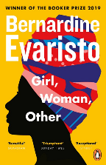 | Evaristo, Bernadine | Girl, Woman, Other  Girl, Woman, Other follows the lives and struggles of twelve very different characters. Mostly women, black and British, they tell the stories of their families, friends and lovers, across the country and through the years.  FICTION
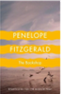 | Fitzgerald, Penelope | The Bookshop  In 1959, widow Florence Green opens a bookshop in the sleepy English town of Hardborough, hoping to enrich the community with literature. Her quiet ambition meets fierce resistance from local elites, especially Violet Gamart, who wants the building for an arts centre. A poignant, understated novel about resilience, small-town politics, and the quiet power of books.  FICTION
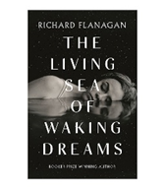 | Flanagan, Richard | The Living Sea of Waking Dreams  The Living Sea of Waking Dreams follows Anna as she battles her mother's decline, insisting on last-ditch therapies in the way only those with power and money can. Are her actions a ferocious form of love, sublimated guilt, or a fearful evasion of love's most intimate and painful obligations? Anna does not know.  FICTION
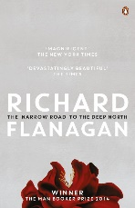 | Flanagan, Richard | The Narrow Road to the Deep North  The Narrow Road to the Deep North follows Australian surgeon Dorrigo Evans as he struggles with memories of his brutal time as a POW on the Thai–Burma Railway and a forbidden love that haunts him. It is a powerful story about the enduring trauma of war, guilt, and the fragile nature of heroism.  FICTION
 | Fraser, Antonia | Marie Antoinette—The Journey  France's iconic queen, Marie Antoinette, wrongly accused of uttering the infamous "Let them eat cake," was alternately revered and reviled during her lifetime. For centuries since, she has been the object of debate, speculation, and the fascination so often accorded illustrious figures in history. Married in mere girlhood, this essentially lighthearted child was thrust onto the royal stage and commanded by circumstance to play a significant role in European history.  NON-FICTION
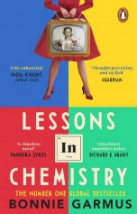 | Garmus, Bonnie | Lessons in Chemistry  Lessons in Chemistry follows Elizabeth Zott as she navigates the treacherous and misogynistic 1950's society and workplace. First as a woman of intellect trying to make it in a “man's profession” and then as a single mother, fighting tooth and nail to keep herself and her child alive.  FICTION
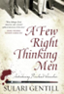 | Gentill, Sulari | A Few Right Thinking Men  Meet Rowland Sinclair, gentleman and artist living in 1931 Sydney. Friend of the Left, son of the Right, he paints in a superbly tailored, three-piece suit and houses friends who include a poet, a painter, and a feminist sculptress whom he has painted nude and hung it in the drawing room. Is he perhaps in love with Edna? If so, she isn’t having any.  FICTION
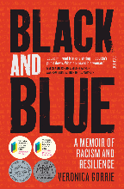 | Gorrie, Veronia | Black and Blue  In this powerful memoir, Gunai/Kurnai woman Veronica Gorrie recounts her decade as one of the few Aboriginal officers in the Queensland Police. With courage and wit, she exposes the racism, sexism, and trauma she faced, while reflecting on her family, identity, and resilience. A compelling story of survival and truth-telling that challenges systems and inspires change  No reading notes  NON-FICTION
 | Greenwood, Kerry | Cassandra  Cassandra, the golden-haired princess cursed with the gift of prophecy, and Diomenes, the Achaean with the healing hands, become puppets of the gods. Their passions are thwarted, their loves betrayed, their gifts rendered useless for the sake of a wager between two immortals. Will Cassandra and Diomenes find each other in the light of the burning city? And, if they do, can their love survive the machinations of malicious gods and men?  No reading notes  FICTION
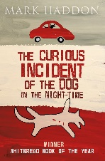 | Haddon, Mark | The Curious Incident of the Dog in the Night-Time  Christopher is 15 and lives in Swindon with his father. He has Asperger's Syndrome, a form of autism. He is obsessed with maths, science and Sherlock Holmes but finds it hard to understand other people. When he discovers a dead dog on a neighbour's lawn he decides to solve the mystery and write a detective thriller about it. As in all good detective stories, the more he unearths, the deeper the mystery gets.  FICTION
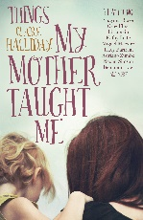 | Halliday, Claire | Things My Mother Taught Me  This heartfelt collection features personal reflections from prominent Australians on the lessons, love, and complexities of their relationships with their mothers. From warmth and wisdom to hardship and healing, these stories explore how maternal influence shapes identity, values, and life paths. A moving tribute to the power of nurture and memory  NON-FICTION
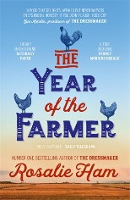 | Ham, Rosalie | The Year of the Farmer  A story of love, justice and survival in a country town at war with the elements and one another. In a close-knit rural community, and especially one plagued by years of drought and secrets, it doesn't take much to ignite an all-out war.  FICTION
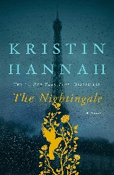 | Hannah, Kristin | The Nightingale  The Nightingale follows French sisters Vianne and Isabelle as they navigate the dangers of Nazi-occupied France. Vianne fights to protect her family at home, while Isabelle joins the Resistance, risking her life to help others escape. Their stories reveal the courage, sacrifice, and resilience of women during wartime.  FICTION
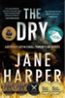 | Harper, Jane | The Dry  In the grip of the worst drought in a century, the farming community of Kiewarra is facing life and death choices daily when three members of a local family are found brutally slain. Federal Police investigator Aaron Falk reluctantly returns to his hometown for the funeral of his childhood friend, loath to face the townsfolk who turned their backs on him twenty years earlier. But as questions mount, Falk is forced to probe deeper into the deaths of the Hadler family.  FICTION
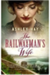 | Hay, Ashley | The Railwayman’s Wife  The Railwayman's Wife explores the power of beginnings and endings, and how hard it can sometimes be to tell them apart. Most of all, it celebrates love in all its forms, and the beauty of discovering that loving someone can be as extraordinary as being loved yourself.  FICTION
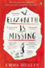 | Healey, Emma | Elizabeth is Missing  “Elizabeth is Missing combines a gripping mystery with a tender yet unflinching exploration of one woman's struggle with dementia. When her best friend Elizabeth goes missing, Maud is convinced that something terrible has happened, and sets out to solve the mystery  FICTION
 | Henry-Jones, Eliza | Ache  A year ago, a devastating bushfire ripped Annie's world apart - killing her grandmother, traumatizing her young daughter and leaving her mother's home in the mountain’s half destroyed. Annie fled back to the city, but the mountain continues to haunt her. Now, drawn by a call for help from her uncle, she's going back to the place she loves most in the world, to try to heal herself, her marriage, her daughter  FICTION
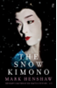 | Henshaw, Mark | The Snow Kimono  On the same day that retired police inspector Auguste Jovert receives a letter from a woman claiming to be his daughter, he returns to his Paris apartment to find a stranger waiting for him. That stranger is a Japanese professor called Tadashi Omura. What's brought him to Jovert's doorstep is not clear, but then he begins to tell his story - a story of a fractured friendship, lost lovers, orphaned children, and a body left bleeding in the snow.  FICTION
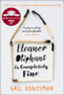 | Honeyman, Gail | Eleanor Oliphant Is Completely Fine  Meet Eleanor Oliphant: She struggles with appropriate social skills and tends to say exactly what she’s thinking. Nothing is missing in her carefully timetabled life of avoiding social interactions, where weekends are punctuated by frozen pizza, vodka, and phone chats with Mummy.  FICTION
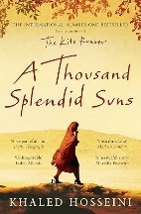 | Hosseini, Khaled | A Thousand Splendid Suns  Mariam is only fifteen when she is sent to Kabul to marry Rasheed. Nearly two decades later, a friendship grows between Mariam and a local teenager, Laila, as strong as the ties between mother and daughter. When the Taliban take over, life becomes a desperate struggle against starvation, brutality and fear. Yet love can move a person to act in unexpected ways and lead them to overcome the most daunting obstacles with a startling heroism.  FICTION
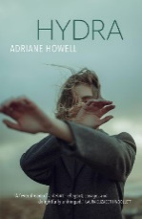 | Howell, Adriane | Hydra  Anja is a young, ambitious antiquarian, passionate for the clean and balanced lines of mid-century furniture. She is intent on classifying objects based on emotional response and when her career goes awry, Anja finds herself adrift. Like a close friend, she confesses her intimacies and rage to us with candour, tenderness, and humour.  FICTION
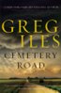 | Iles, Greg | Cemetery Road  Marshall McEwan is one of the most successful journalists in Washington, DC. He returns home to face buried secrets, a powerful elite, and a deadly conspiracy that could destroy everything he thought he knew.  FICTION
 | Jonasson, Jonas | The One Hundred Year Old Man Who Climbed Out of the Window and Disappeared  After a long and eventful life, Allan Karlsson ends up in a nursing home, believing it to be his last stop. The only problem is that he’s still in good health. A big celebration is in the works for his 100th birthday, but Allan really isn’t interested. He climbs out the window in his slippers and embarks on a hilarious and entirely unexpected journey.  FICTION
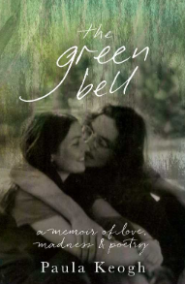 | Keogh, Paula | The Green Bell  In 1972, Michael Dransfield and Paula Keogh meet in a psychiatric ward in Canberra and fall in love. Together, they embrace a dream of living life as a poem, but once outside the hospital, they face challenges that test their love. The Green Bell is a poignant exploration of love, madness, and the search for a truer life. It is a memoir that reflects on lost friends and the lifelong journey of self-discovery.  NON-FICTION
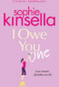 | Kinsella, Sophie | I Owe You One  Fixie Farr has a habit she can’t break—fixing everything and everyone around her. When a charming stranger asks her to watch his laptop at a café, she naturally steps in and even saves it from disaster. Grateful, he leaves her an IOU, though Fixie has no intention of using it. But this small act of kindness soon sets off a chain of events that might just turn her carefully ordered world upside down.  FICTION
 | Langbroek, Kate | Six Take Italy  In this warm and witty memoir, Kate Langbroek recounts her dream of an idyllic Italian life—sunny piazzas, leisurely lunches, and charming calls of “Ciao Bella!”—and the reality of uprooting her family to Bologna. With humour and heart, she explores what the Italians teach us about joy, resilience, and focusing on what truly matters, especially when the world feels like it’s falling apart.  No reading notes  NON-FICTION
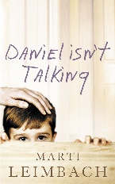 | Leimbach, Marti | Daniel Isn’t Talking  A moving, deeply absorbing story of a family in crisis. What sets it apart from most fiction about difficult subjects such as autism, is the author's ability to write about a sad and frightening situation with a seamless blend of warmth, compassion and humour.  FICTION
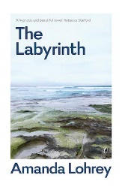 | Lohrey, Amanda | The Labyrinth: A Pastoral  After her son is jailed for a violent crime, Erica retreats to a coastal village, where building a labyrinth helps her face grief, accept help from strangers, and confront the guilt and memories she’s long avoided.  FICTION
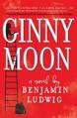 | Ludwig, Benjamin | Ginny Moon  Ginny Moon is exceptional. Everyone knows it—especially her new adoptive parents. They all love her, even if they don't quite understand her. They want her to feel like she belongs. What they don't know is that Ginny has no intention of belonging. She's found her birth-mother on facebook, and is determined to get back to her, no matter the cost because Ginny left something behind and she's desperate to get it back, to make things right. But no one listens or understands. So Ginny takes matters into her own hands…  FICTION
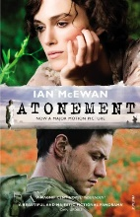 | McEwan, Ian | Atonement  A British novel written by Ian McEwan. Set in three time periods, 1935 England, Second World War England and France, and present-day England, it covers an upper-class girl's half-innocent mistake that ruins lives, her adulthood in the shadow of that mistake, and a reflection on the nature of writing.  FICTION
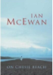 | McEwan, Ian | On Chesil Beach  It is July 1962. Florence is a talented musician who dreams of a career on the concert stage and of the perfect life she will create with Edward, an earnest young history student at University College of London, who unexpectedly wooed and won her heart. Newly married that morning, both virgins, Edward and Florence arrive at a hotel on the Dorset coast. At dinner in their rooms they struggle to suppress their worries about the wedding night to come.  FICTION
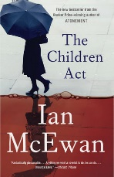 | McEwan, Ian | The Children Act  A compelling novel by Ian McEwan about a High Court judge facing a life-or-death decision when a teenage boy refuses medical treatment on religious grounds. Their meeting changes both their lives in unexpected ways.  Fiction
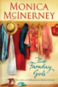 | McInerney, Monica | Those Faraday Girls  As a child, Maggie Faraday grew up in a lively, unconventional household with her young mother, four very different aunts and her eccentric grandfather. With her mother often away, her aunts took turns to look after her - until, just weeks before Maggie's sixth birthday, a shocking event changed everything. Twenty years on, Maggie is living alone in New York City when a surprise visit from her grandfather brings a revelation and a proposition to reunite the family.  FICTION
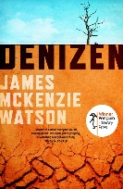 | Mackenzie Watson, James | Denizen  Denizen is a gothic-style thriller that explores rural Australia’s harsh country and stoic people – a tension that forces its inhabitants to dangerous breaking points. When nine-year-old Parker starts feeling like something is wrong with his brain, he desperately seeks control in attempts that culminate in deadly and devastating ways.  FICTION
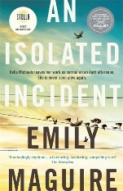 | Maguire, Emily | An Isolated Incident  When Bella Michaels is murdered in a small Australian town, her sister Chris is thrust into the media spotlight. This gripping novel explores grief, misogyny, and the impact of violence on women, shifting focus from solving the crime to the emotional aftermath and societal response. A powerful, character-driven story that challenges crime fiction conventions. A psychological thriller.  FICTION
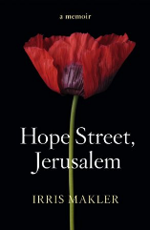 | Makler, Irris | Hope Street, Jerusalem  Irris Makler blends love and danger in a powerful story set in Jerusalem, a city where even the smallest decisions can have life-or-death consequences. As a roving foreign correspondent covering volatile events, Makler weaves a personal narrative of falling in love with a young Israeli, navigating her challenging work, and embracing the complexities of life in a city marked by both conflict and hope.  Through her eyes, readers gain an intimate, heartfelt view of a city often misunderstood, shining a light on the resilience of love in the face of adversity.  NON-FICTION
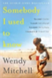 | Mitchell, Wendy | Somebody I Used to Know  Wendy Mitchell had a busy job with the British National Health Service, raised her two daughters alone, and spent her weekends running and climbing mountains. Then, slowly, a mist settled deep inside the mind she once knew so well, blurring the world around her. She didn't know it then, but dementia was starting to take hold. In 2014, at age fifty-eight, she was diagnosed with young-onset Alzheimer's. Mitchell was determined and resourceful, and vowed to outwit the disease for as long as she could.  NON-FICTION
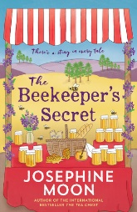 | Moon, Josephine | The Beekeeper’s Secret  High in the mountains, Maria Lindsey, a reclusive former nun lives a quiet life—until two letters unlock a past she’s tried to forget. As her world collides with Tansy Butterfield’s, secrets unravel, threatening everything they thought they knew about love, guilt, and forgiveness.  FICTION
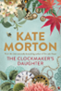 | Morton, Kate | The Clockmakers Daughter  In the summer of 1862, a group of young artists led by the passionate and talented Edward Radcliffe descends upon Birchwood Manor on the banks of the Thames. Their plan: to spend a secluded month in a haze of inspiration and creativity. But by the time their stay is over, one woman has been shot dead while another has disappeared; a priceless heirloom is missing; and Edward Radcliffe’s life is in ruins.  FICTION
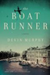 | Murphy, Devin | The Boat Runner  A Dutch seafarer turned smuggler at the beginning of World War II. Beginning in the summer of 1939, fourteen-year-old Jacob Koopman and his older brother, Edwin, enjoy lives of prosperity and quiet contentment. Many of the residents in their small Dutch town have some connection to the Koopman lightbulb factory, and the locals hold the family in high esteem…  FICTION
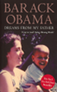 | Obama, Barack | Dreams from my Father  In this deeply personal memoir, Barack Obama traces his journey from childhood to adulthood, exploring race, identity, and family. Written before his presidency, it offers a candid look at his search for belonging and the legacy of his Kenyan father.  NON-FICTION
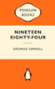 | Orwell, George | Nineteen Eighty-Four  George Orwell’s Nineteen Eighty-Four is a chilling and influential 20th‑century novel that portrays a bleak, totalitarian future where individuality is crushed by an all‑powerful state. First published in 1949, it remains hauntingly relevant for its sharp satire, its foresight about technology and language manipulation, and its unforgettable depiction of one man’s struggle for personal freedom in a world designed to destroy it.  FICTION
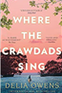 | Owens, Delia | Where the Crawdads Sing  Abandoned and wild, Kya Clark grows up alone in the marshes—until a shocking murder in town casts her into suspicion. As secrets unravel, her story becomes one of fierce survival, haunting love, and the unforgiving judgment of a divided community.  FICTION
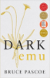 | Pascoe, Bruce | Dark Emu  Dark Emu puts forward an argument for a reconsideration of the hunter-gatherer tag for precolonial Aboriginal Australians. The evidence insists that Aboriginal people right across the continent were using domesticated plants, sowing, harvesting, irrigating and storing – behaviours inconsistent with the hunter-gatherer tag.  NON-FICTION
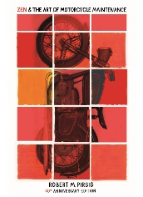 | Pirsig, Robert | Zen and the Art of Motorcycle Maintenance  A philosophical journey across America that explores the meaning of “Quality” through motorcycle maintenance, fatherhood, and self-discovery.  NON-FICTION
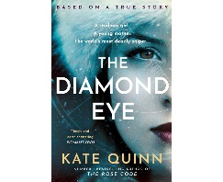 | Quinn, Kate | The Diamond Eye – coming soon  Based on a true story, this gripping novel follows Mila Pavlichenko, a young mother turned deadly sniper during WWII. As she rises to fame on the Eastern Front, she’s sent to America where an unexpected friendship with Eleanor Roosevelt offers hope—until a dangerous enemy resurfaces.  FICTION
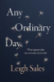 | Sales, Leigh | An Ordinary Day  As a journalist, Leigh Sales often encounters people experiencing the worst moments of their lives in the full glare of the media. But one particular string of bad news stories - and a terrifying brush with her own mortality - sent her looking for answers about how vulnerable each of us is to a life-changing event.  NON-FICTION
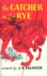 | Salinger, J.D. | The Catcher in the Rye  The hero-narrator of The Catcher in the Rye is an ancient child of sixteen, a native New Yorker named Holden Caulfield. Through circumstances that tend to preclude adult, second-hand description, he leaves his prep school in Pennsylvania and goes underground in New York City for three days. The boy himself is at once too simple and too complex for us to make any final comment about him or his story.  FICTION
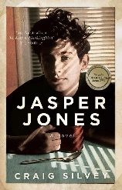 | Silvey, Craig | Jasper Jones  When Charlie Bucktin is pulled into a midnight secret by the town’s outcast, Jasper Jones, he’s forced to confront a terrifying truth. In one life-changing summer, Charlie faces fear, injustice, and heartbreak—and discovers the painful weight of growing up.  FICTION
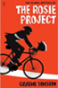 | Simsion, Graeme | The Rosie Project  Don Tillman, professor of genetics, has never been on a second date. He is a man who can count all his friends on the fingers of one hand, whose lifelong difficulty with social rituals has convinced him that he is simply not wired for romance. So when an acquaintance informs him that he would make a “wonderful” husband, his first reaction is shock. Yet he must concede to the statistical probability that there is someone for everyone, and he embarks upon The Wife Project.  FICTION
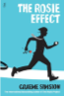 | Simsion, Graeme | The Rosie Effect  The book follows Don's attempts to prepare for parenthood and to support Rosie in her own preparation, drawing on science and the unreliable advice of his friends. Don's unconventional approach alienates Rosie and eventually leads to the breakdown of their marriage. Don pursues Rosie and persuades her to return.  FICTION
 | Simsion, Graeme | The Rosie Result  The Rosie Effect (2014) found Don and Rosie ten months into marriage, living in New York and expecting a child. Simsion wraps up the series with The Rosie Result, which is largely focused on Don's latest campaign — to spare his brilliant but awkward 11-year-old son Hudson the unhappiness he experienced growing up.  FICTION
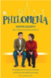 | Sixsmith, Martin | Philomena  In 1952, Irish teenager Philomena (Judi Dench) became pregnant out of wedlock and was sent to a convent. When her baby, Anthony, was a toddler, the nuns took Philomena's child away from her and put him up for adoption in the United States. For the next 50 years, she searched tirelessly for her son. When former BBC correspondent Martin Sixsmith (Steve Coogan) learns of the story, he becomes her ally. They travel together to America to find Anthony and become unexpectedly close in the process.  FICTION
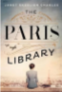 | Skeslien, Charles, Janet | The Paris Library  When the Nazis march into Paris, Odile stands to lose everything she holds dear, including her beloved library. Together with her fellow librarians, Odile joins the Resistance with the best weapons she has books. But when the war finally ends, instead of freedom, Odile tastes the bitter sting of unspeakable betrayal.  FICTION
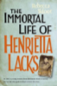 | Skloot, Rebecca | The Immortal Life of Henrietta Lacks  Henrietta Lacks, as HeLa, is known to present-day scientists for her cells from cervical cancer. She was a poor Southern tobacco farmer who worked the same land as her slave ancestors, yet her cells were taken without her knowledge and still live decades after her death. Cells descended from her may weigh more than 50M metric tons.  NON-FICTION
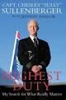 | Sullenberger, Capt. Chesley ‘Sully’ | Highest Duty, my Search for What Really Matters  A moving memoir by Captain “Sully” Sullenberger, the pilot who safely landed US Airways Flight 1549 on the Hudson River. This inspiring story reflects on his life, values, and the moments that shaped his extraordinary act of courage. Now a major motion picture based on the inspirational autobiography.  NON-FICTION
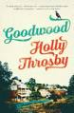 | Throsby, Holly | Goodwood  Goodwood is a small town where everyone knows everything about everyone. In 1992, when Jean Brown is seventeen, a terrible thing happens. Rosie White, the coolest girl in town, vanishes overnight. A week later, Goodwood's most popular resident, Bart Mcdonald, sets off on a fishing trip and never comes home. As the intensity of speculation heightens, Jean, who is keeping secrets of her own, and the rest of Goodwood are left reeling.  FICTION
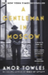 | Towles, Amor | A Gentleman in Moscow  In 1922, Count Alexander Rostov is deemed an unrepentant aristocrat by a Bolshevik tribunal, and is sentenced to house arrest in a grand hotel across the street from the Kremlin. Rostov has never worked a day in his life, and must now live in an attic during some of the most tumultuous decades in Russian history. Unexpectedly, his circumstances provide him entry into a much larger world of emotional discovery.  FICTION
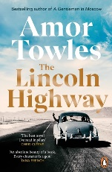 | Towles, Amor | The Lincoln Highway  In 1954, 18-year-old Emmett Watson is released from juvenile detention and plans to start fresh with his younger brother Billy by heading west. But when two former bunkmates hijack his plans, the brothers are swept into an unexpected journey eastward. Told through multiple perspectives, this richly layered novel explores friendship, redemption, and the pursuit of dreams across a ten-day road trip through mid-century America.  FICTION
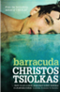 | Tsiolkas, Christos | Barracuda  Set from 1996, Danny Kelly is a talented swimmer who attends a prestigious Melbourne private school on a sporting scholarship. ... He is taken under the wing of highly regarded coach Frank Torma and develops a friendship/rivalry with teammate Martin Taylor which inspires Danny to become a world record holder.  FICTION
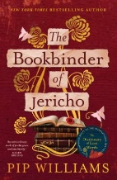 | Williams, Pip | The Bookbinder of Jericho  Set in 1914 as war pulls Britain’s young men to the front, The Bookbinder of Jericho follows sisters Peggy and Maude, who work in the bindery at Oxford University Press. Through their experiences, Pip Williams offers a richly drawn, women‑centred view of history, exploring who creates knowledge, who is allowed access to it, and what is lost when it is withheld.  FICTION
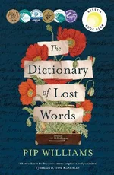 | Williams, Pip | The Dictionary of Lost Words  In 1901, the word 'Bondmaid' was discovered missing from the Oxford English Dictionary. This is the story of the girl who stole it. Esme is born into a world of words. She spends her childhood in the 'Scriptorium', a garden shed in Oxford where her father and a team of lexicographers are collecting words for the very first Oxford English Dictionary. Esme realises that some words are considered more important than others. While she dedicates her life to the Oxford English Dictionary, secretly, she begins to collect words for another dictionary: The Dictionary of Lost Words. Set when the women's suffrage movement was at its height and the Great War loomed.  FICTION
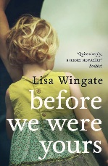 | Wingate, Lisa | Before We Were Yours  Based on a shocking true scandal, this dual-timeline novel follows twelve-year-old Rill Foss, who is taken from her riverboat family in 1939 and placed in a corrupt orphanage. Decades later, a modern-day woman uncovers hidden family secrets that challenge everything she thought she knew. A poignant story of loss, resilience, and the enduring bonds of family.  FICTION
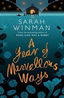 | Winman, Sarah | A Year of Marvellous  Ways Cornwall, 1947. Marvellous Ways is a ninety-year-old woman who's lived alone in a remote creek for nearly all her life. Recently she's taken to spending her days sitting on the steps of her caravan with a pair of binoculars. She's waiting for something - she's not sure what, but she'll know it when she sees it. Freddy Drake is a young soldier left reeling by the war.  No reading notes  FICTION
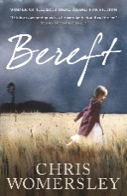 | Womersley, Chris | Bereft  In 1919, after World War I, Australia is gripped by the Spanish flu with tight travel restrictions and widespread fear. Quinn Walker returns to his hometown, fleeing from accusations of a past crime, knowing his family would condemn him. Hiding in the hills, he encounters Sadie Fox, an orphan with unsettling knowledge about the crime. As tension rises, Quinn must confront his past while navigating the dangers of both the epidemic and his own family’s wrath.  FICTION
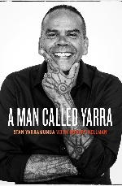 | Yarramunua, Stan | A Man Called Yarra  From a rough childhood in Swan Hill to international recognition, Stan ‘Yarra’ Yarramunua’s journey is one of resilience, cultural pride, and redemption. Battling addiction and hardship, he finds healing through art—and a powerful purpose in helping others rise.  NON-FICTION

