
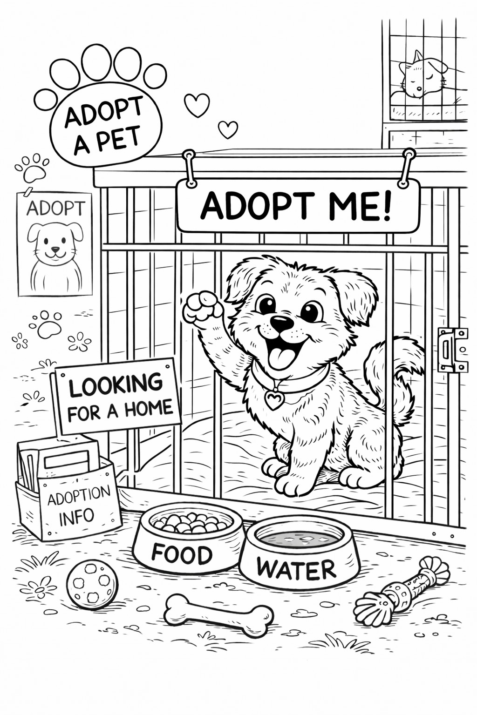

East Gippsland Shire Council colouring-in competition
What to do

Colour in the picture using any colours you like.

Name:_______________________________________
Age:________________________________________
Phone number:_______________________________

Where to submit:
Hand in your completed colouring-in sheet to East Gippsland Council Community Laws Officers at one of the following locations:
- Orbost Show 2026
- East Gippsland Field Days 2026

Hand deliver or mail your entry to:
East Gippsland Shire Council
Att: Community Laws
273 Main St (PO Box 1618)
Bairnsdale VIC 3875

Submissions close Saturday 11 April, 2026

Winners will be contacted directly and announced on Council’s social media channels.

